

Reading & Literacy Strategy to Address the Lockdown Gap

Overview:
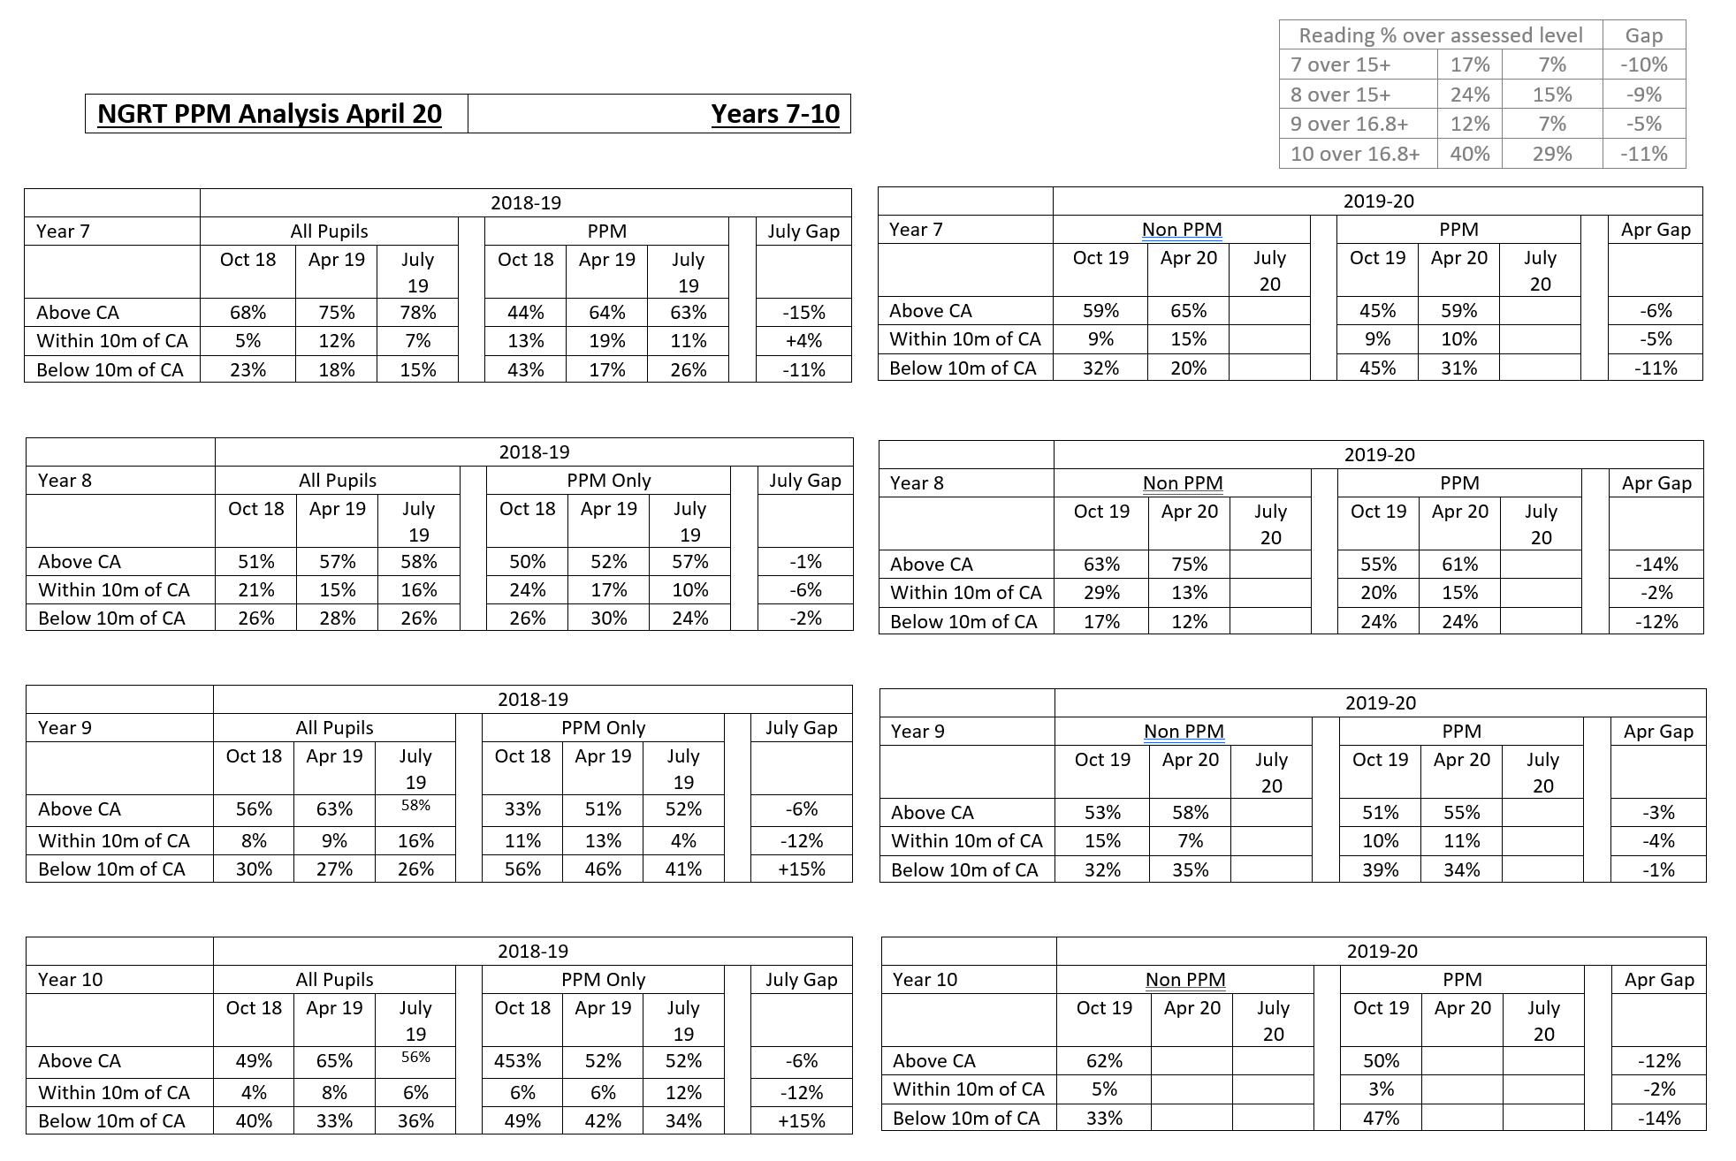
The majority of our students will have been away from school for over 5 months. Before schools closed, reading age data was promising and students were on track to make significant progress by the end of Term 3.

During school closures, submission rate has been poor and students quizzing on Accelerated Reader has declined over the period.

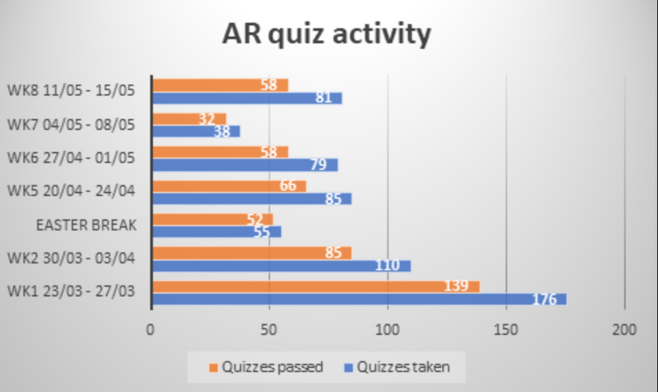
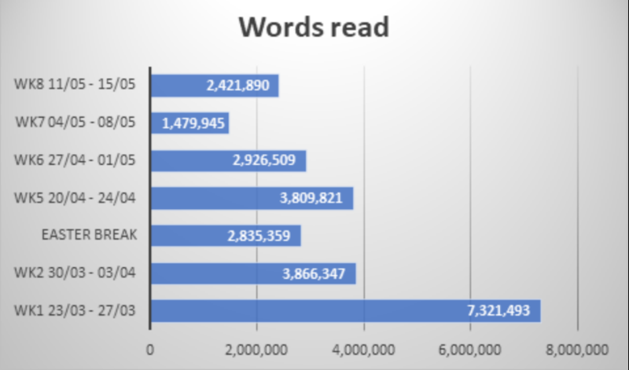

Tutor Reading is still taking place for home learning. Staff members are recording and uploading daily readings of books for each year group. Views are consistent and are similar/better than other schools offering a similar provision.
Barriers:
Apart from students quizzing via AR, there is no way to tell if and how much students are reading on a regular basis. Many students won’t have much, if any, physical reading at home. Many online reading resources have been shared regularly with students, but access could be an issue as well as motivation and encouragement from parents. Historically, students of our weakest readers have not been the most supportive of our reading strategies (for e.g. not attending Reading Log launch events or signing the Reading Log/Report on a regular basis.)

Plan:
Our weakest readers will need the most support as their reading age is most likely to have suffered during the lockdown period. These students will be targeted for key intervention upon return in September.
Proposal 1 – These weakest students will attend small reading groups during Tutor Time in the Library or an unused classroom with a TA or member of staff with no Tutor Group. During this time, the group will read a text together. The staff member should lead the reading and then invite the students in turn to read a few lines aloud. The group text will be chosen specifically for the reading age of that group to give a balance of accessibility and challenge. To keep these students in Tutor Reading may not be beneficial as many of those texts are challenging.
Proposal 2 – These weakest students will also have priority of 1-2-1 reading during fortnightly Library Lessons with their English teachers. TAs and Sixth Form volunteers can be used during these lessons to ensure as many of our weakest students are exposed to as much reading support as possible.
Proposal 3 – Literacy Reps keep in regular contact with KVI and prioritise reading in the classroom in subject areas.
Proposal 4 – Reading Logs are launched again but more highly monitored with phone calls home to parents to maximise engagement. KVI to regularly meet with those students too (coincides with Proposal 1).
Proposal 5 – NGRT conducted ASAP to get accurate reading age data so target students can be identified and start intervention.
Proposal 6 – Whole staff session on Literacy/Reading in September to share reading age data/impact of lockdown and to make closing the gap a whole school focus.
Year 6/7 Transition:
Year 6 students who come in for Transition Day normally receive a ‘gift of summer reading’ and a letter home detailing the importance and value NA places on reading. In light of this not happening, enquiries are being made with the author in the hope we can give students access to an e-book version. Also, as this is part of our annual LitFest celebration, authors have been contacted to see if we can still have some sort of virtual version of the event, with authors making videos especially for our students. This will ensure all students, including our newest cohort, share the school’s vision on the importance of reading.

During Lockdown:
- Continual promotion of free online reading
- Staff tweets of what they are reading/quizzing
- Tutor Reading raffle prizes
- *NEW* Reading Bingo card – students encouraged to complete a range of reading activities during the next half term to win prizes
- Summer Reading Challenge
- Virtual LitFest

KVI to monitor the Literacy community and attend webinars/CPD sessions and update plan as and when.

