


KS3 English

Writing Booklet

Activities

Name:
Class:
Teacher:

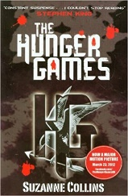
This Home Learning Writing Booklet has been designed for you to be able to type in or print out and write on. Save a copy and submit to your teacher as a Word Document.
In the reading booklet, you read Chapter One of ‘The Hunger Games’ by Suzanna Collins and then completed some reading activities.
You are now going to complete one of two writing activities inspired by this text.
You are going to enter a creative writing competition.
You can either:
Write a description suggested by this picture.

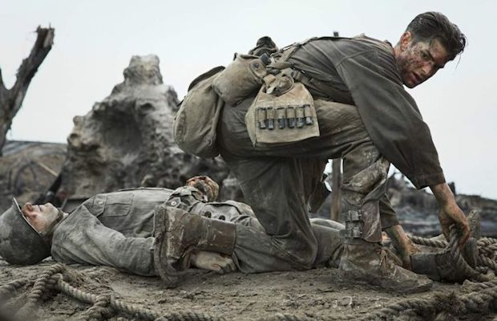

Or write the opening part of a story about a time when you’ve protected somebody.

SUCCESS CRITERIA:
- Use powerful adjectives and verbs;
- Use a range of language techniques e.g. similes, metaphors, personification, pathetic fallacy etc.;
- Use a range of sentence lengths;
- Use a range of punctuation accurately;
- Organise your ideas into paragraphs.

…………………………………………………………………………………………………………………………………………………………….
…………………………………………………………………………………………………………………………………………………………….
…………………………………………………………………………………………………………………………………………………………….
…………………………………………………………………………………………………………………………………………………………….
…………………………………………………………………………………………………………………………………………………………….
…………………………………………………………………………………………………………………………………………………………….
…………………………………………………………………………………………………………………………………………………………….
…………………………………………………………………………………………………………………………………………………………….
…………………………………………………………………………………………………………………………………………………………….
…………………………………………………………………………………………………………………………………………………………….
…………………………………………………………………………………………………………………………………………………………….
…………………………………………………………………………………………………………………………………………………………….
…………………………………………………………………………………………………………………………………………………………….
…………………………………………………………………………………………………………………………………………………………….
…………………………………………………………………………………………………………………………………………………………….
…………………………………………………………………………………………………………………………………………………………….
…………………………………………………………………………………………………………………………………………………………….
…………………………………………………………………………………………………………………………………………………………….
…………………………………………………………………………………………………………………………………………………………….
…………………………………………………………………………………………………………………………………………………………….
…………………………………………………………………………………………………………………………………………………………….
…………………………………………………………………………………………………………………………………………………………….
…………………………………………………………………………………………………………………………………………………………….
…………………………………………………………………………………………………………………………………………………………….
…………………………………………………………………………………………………………………………………………………………….
…………………………………………………………………………………………………………………………………………………………….
…………………………………………………………………………………………………………………………………………………………….
…………………………………………………………………………………………………………………………………………………………….
…………………………………………………………………………………………………………………………………………………………….
…………………………………………………………………………………………………………………………………………………………….
…………………………………………………………………………………………………………………………………………………………….
…………………………………………………………………………………………………………………………………………………………….
…………………………………………………………………………………………………………………………………………………………….
…………………………………………………………………………………………………………………………………………………………….
…………………………………………………………………………………………………………………………………………………………….
…………………………………………………………………………………………………………………………………………………………….
…………………………………………………………………………………………………………………………………………………………….
…………………………………………………………………………………………………………………………………………………………….
…………………………………………………………………………………………………………………………………………………………….
…………………………………………………………………………………………………………………………………………………………….
…………………………………………………………………………………………………………………………………………………………….
…………………………………………………………………………………………………………………………………………………………….
…………………………………………………………………………………………………………………………………………………………….
…………………………………………………………………………………………………………………………………………………………….
…………………………………………………………………………………………………………………………………………………………….
…………………………………………………………………………………………………………………………………………………………….
…………………………………………………………………………………………………………………………………………………………….
…………………………………………………………………………………………………………………………………………………………….
…………………………………………………………………………………………………………………………………………………………….
…………………………………………………………………………………………………………………………………………………………….
…………………………………………………………………………………………………………………………………………………………….
…………………………………………………………………………………………………………………………………………………………….
…………………………………………………………………………………………………………………………………………………………….
…………………………………………………………………………………………………………………………………………………………….
…………………………………………………………………………………………………………………………………………………………….
…………………………………………………………………………………………………………………………………………………………….
…………………………………………………………………………………………………………………………………………………………….
…………………………………………………………………………………………………………………………………………………………….
…………………………………………………………………………………………………………………………………………………………….
…………………………………………………………………………………………………………………………………………………………….
…………………………………………………………………………………………………………………………………………………………….
…………………………………………………………………………………………………………………………………………………………….
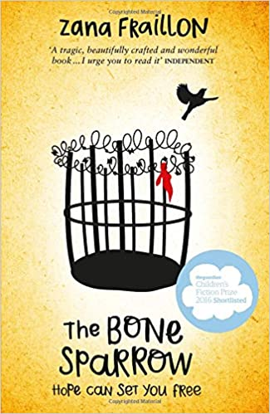
For the second task, you read Chapter One of ‘The Bone Sparrow’ by Zana Fraillon and then completed some reading activities.
You are now going to complete one of two writing activities inspired by this text.
You are going to enter a creative writing competition.
You can either:
Write a description suggested by this picture.
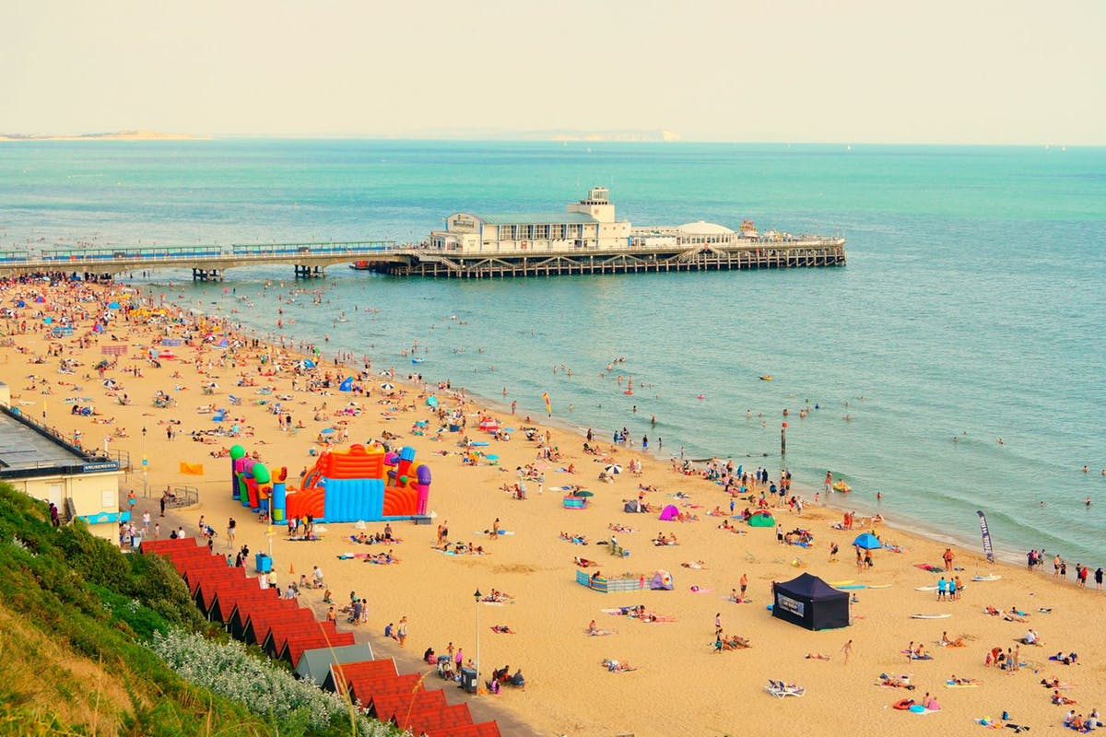

Or write the opening part of a story about a time when friendship has been important to you.

SUCCESS CRITERIA:
- Use powerful adjectives and verbs;
- Use a range of language techniques e.g. similes, metaphors, personification, pathetic fallacy etc.;
- Use a range of sentence lengths;
- Use a range of punctuation accurately;
- Organise your ideas into paragraphs.

…………………………………………………………………………………………………………………………………………………………….
…………………………………………………………………………………………………………………………………………………………….
…………………………………………………………………………………………………………………………………………………………….
…………………………………………………………………………………………………………………………………………………………….
…………………………………………………………………………………………………………………………………………………………….
…………………………………………………………………………………………………………………………………………………………….
…………………………………………………………………………………………………………………………………………………………….
…………………………………………………………………………………………………………………………………………………………….
…………………………………………………………………………………………………………………………………………………………….
…………………………………………………………………………………………………………………………………………………………….
…………………………………………………………………………………………………………………………………………………………….
…………………………………………………………………………………………………………………………………………………………….
…………………………………………………………………………………………………………………………………………………………….
…………………………………………………………………………………………………………………………………………………………….
…………………………………………………………………………………………………………………………………………………………….
…………………………………………………………………………………………………………………………………………………………….
…………………………………………………………………………………………………………………………………………………………….
…………………………………………………………………………………………………………………………………………………………….
…………………………………………………………………………………………………………………………………………………………….
…………………………………………………………………………………………………………………………………………………………….
…………………………………………………………………………………………………………………………………………………………….
…………………………………………………………………………………………………………………………………………………………….
…………………………………………………………………………………………………………………………………………………………….
…………………………………………………………………………………………………………………………………………………………….
…………………………………………………………………………………………………………………………………………………………….
…………………………………………………………………………………………………………………………………………………………….
…………………………………………………………………………………………………………………………………………………………….
…………………………………………………………………………………………………………………………………………………………….
…………………………………………………………………………………………………………………………………………………………….
…………………………………………………………………………………………………………………………………………………………….
…………………………………………………………………………………………………………………………………………………………….
…………………………………………………………………………………………………………………………………………………………….
…………………………………………………………………………………………………………………………………………………………….
…………………………………………………………………………………………………………………………………………………………….
…………………………………………………………………………………………………………………………………………………………….
…………………………………………………………………………………………………………………………………………………………….
…………………………………………………………………………………………………………………………………………………………….
…………………………………………………………………………………………………………………………………………………………….
…………………………………………………………………………………………………………………………………………………………….
…………………………………………………………………………………………………………………………………………………………….
…………………………………………………………………………………………………………………………………………………………….
…………………………………………………………………………………………………………………………………………………………….
…………………………………………………………………………………………………………………………………………………………….
…………………………………………………………………………………………………………………………………………………………….
…………………………………………………………………………………………………………………………………………………………….
…………………………………………………………………………………………………………………………………………………………….
…………………………………………………………………………………………………………………………………………………………….
…………………………………………………………………………………………………………………………………………………………….
…………………………………………………………………………………………………………………………………………………………….
…………………………………………………………………………………………………………………………………………………………….
…………………………………………………………………………………………………………………………………………………………….
…………………………………………………………………………………………………………………………………………………………….
…………………………………………………………………………………………………………………………………………………………….
…………………………………………………………………………………………………………………………………………………………….
…………………………………………………………………………………………………………………………………………………………….
…………………………………………………………………………………………………………………………………………………………….
…………………………………………………………………………………………………………………………………………………………….
…………………………………………………………………………………………………………………………………………………………….
…………………………………………………………………………………………………………………………………………………………….
…………………………………………………………………………………………………………………………………………………………….
…………………………………………………………………………………………………………………………………………………………….
…………………………………………………………………………………………………………………………………………………………….
For the third task, you read Chapter One of ‘Harry Potter and the Philosopher’s Stone’ by J. K. Rowling and then completed some reading activities.
You are now going to complete one of two writing activities inspired by this text.
You are going to enter a creative writing competition.
You can either:
Write a description suggested by this picture.
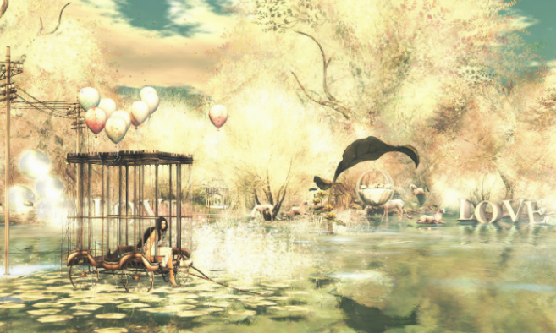

Or write the opening part of a story about a misfit family.

SUCCESS CRITERIA:
- Use powerful adjectives and verbs;
- Use a range of language techniques e.g. similes, metaphors, personification, pathetic fallacy etc.;
- Use a range of sentence lengths;
- Use a range of punctuation accurately;
- Organise your ideas into paragraphs.

…………………………………………………………………………………………………………………………………………………………….
…………………………………………………………………………………………………………………………………………………………….
…………………………………………………………………………………………………………………………………………………………….
…………………………………………………………………………………………………………………………………………………………….
…………………………………………………………………………………………………………………………………………………………….
…………………………………………………………………………………………………………………………………………………………….
…………………………………………………………………………………………………………………………………………………………….
…………………………………………………………………………………………………………………………………………………………….
…………………………………………………………………………………………………………………………………………………………….
…………………………………………………………………………………………………………………………………………………………….
…………………………………………………………………………………………………………………………………………………………….
…………………………………………………………………………………………………………………………………………………………….
…………………………………………………………………………………………………………………………………………………………….
…………………………………………………………………………………………………………………………………………………………….
…………………………………………………………………………………………………………………………………………………………….
…………………………………………………………………………………………………………………………………………………………….
…………………………………………………………………………………………………………………………………………………………….
…………………………………………………………………………………………………………………………………………………………….
…………………………………………………………………………………………………………………………………………………………….
…………………………………………………………………………………………………………………………………………………………….
…………………………………………………………………………………………………………………………………………………………….
…………………………………………………………………………………………………………………………………………………………….
…………………………………………………………………………………………………………………………………………………………….
…………………………………………………………………………………………………………………………………………………………….
…………………………………………………………………………………………………………………………………………………………….
…………………………………………………………………………………………………………………………………………………………….
…………………………………………………………………………………………………………………………………………………………….
…………………………………………………………………………………………………………………………………………………………….
…………………………………………………………………………………………………………………………………………………………….
…………………………………………………………………………………………………………………………………………………………….
…………………………………………………………………………………………………………………………………………………………….
…………………………………………………………………………………………………………………………………………………………….
…………………………………………………………………………………………………………………………………………………………….
…………………………………………………………………………………………………………………………………………………………….
…………………………………………………………………………………………………………………………………………………………….
…………………………………………………………………………………………………………………………………………………………….
…………………………………………………………………………………………………………………………………………………………….
…………………………………………………………………………………………………………………………………………………………….
…………………………………………………………………………………………………………………………………………………………….
…………………………………………………………………………………………………………………………………………………………….
…………………………………………………………………………………………………………………………………………………………….
…………………………………………………………………………………………………………………………………………………………….
…………………………………………………………………………………………………………………………………………………………….
…………………………………………………………………………………………………………………………………………………………….
…………………………………………………………………………………………………………………………………………………………….
…………………………………………………………………………………………………………………………………………………………….
…………………………………………………………………………………………………………………………………………………………….
…………………………………………………………………………………………………………………………………………………………….
…………………………………………………………………………………………………………………………………………………………….
…………………………………………………………………………………………………………………………………………………………….
…………………………………………………………………………………………………………………………………………………………….
…………………………………………………………………………………………………………………………………………………………….
…………………………………………………………………………………………………………………………………………………………….
…………………………………………………………………………………………………………………………………………………………….
…………………………………………………………………………………………………………………………………………………………….
…………………………………………………………………………………………………………………………………………………………….
…………………………………………………………………………………………………………………………………………………………….
…………………………………………………………………………………………………………………………………………………………….
…………………………………………………………………………………………………………………………………………………………….
…………………………………………………………………………………………………………………………………………………………….
…………………………………………………………………………………………………………………………………………………………….
…………………………………………………………………………………………………………………………………………………………….
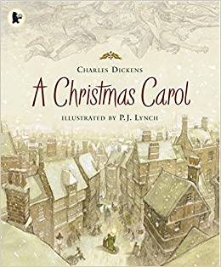
For the fourth task, you read Chapter One of ‘A Christmas Carol’ by Charles Dickens and then completed some reading activities.
You are now going to complete one of two writing activities inspired by this text.
You are going to enter a creative writing competition.
You can either:
Write a description suggested by this picture.
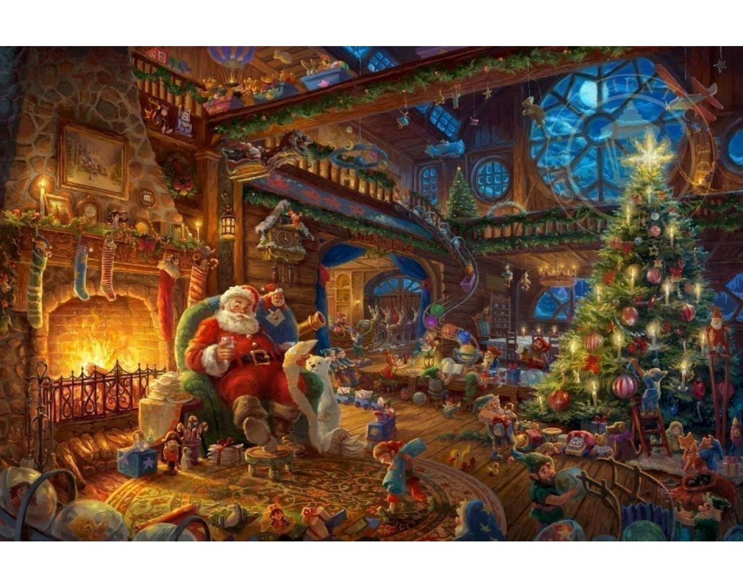
Or write the opening part of a story called ‘A Little Bit of Christmas Magic’.

SUCCESS CRITERIA:
- Use powerful adjectives and verbs;
- Use a range of language techniques e.g. similes, metaphors, personification, pathetic fallacy etc.;
- Use a range of sentence lengths;
- Use a range of punctuation accurately;
- Organise your ideas into paragraphs.

…………………………………………………………………………………………………………………………………………………………….
…………………………………………………………………………………………………………………………………………………………….
…………………………………………………………………………………………………………………………………………………………….
…………………………………………………………………………………………………………………………………………………………….
…………………………………………………………………………………………………………………………………………………………….
…………………………………………………………………………………………………………………………………………………………….
…………………………………………………………………………………………………………………………………………………………….
…………………………………………………………………………………………………………………………………………………………….
…………………………………………………………………………………………………………………………………………………………….
…………………………………………………………………………………………………………………………………………………………….
…………………………………………………………………………………………………………………………………………………………….
…………………………………………………………………………………………………………………………………………………………….
…………………………………………………………………………………………………………………………………………………………….
…………………………………………………………………………………………………………………………………………………………….
…………………………………………………………………………………………………………………………………………………………….
…………………………………………………………………………………………………………………………………………………………….
…………………………………………………………………………………………………………………………………………………………….
…………………………………………………………………………………………………………………………………………………………….
…………………………………………………………………………………………………………………………………………………………….
…………………………………………………………………………………………………………………………………………………………….
…………………………………………………………………………………………………………………………………………………………….
…………………………………………………………………………………………………………………………………………………………….
…………………………………………………………………………………………………………………………………………………………….
…………………………………………………………………………………………………………………………………………………………….
…………………………………………………………………………………………………………………………………………………………….
…………………………………………………………………………………………………………………………………………………………….
…………………………………………………………………………………………………………………………………………………………….
…………………………………………………………………………………………………………………………………………………………….
…………………………………………………………………………………………………………………………………………………………….
…………………………………………………………………………………………………………………………………………………………….
…………………………………………………………………………………………………………………………………………………………….
…………………………………………………………………………………………………………………………………………………………….
…………………………………………………………………………………………………………………………………………………………….
…………………………………………………………………………………………………………………………………………………………….
…………………………………………………………………………………………………………………………………………………………….
…………………………………………………………………………………………………………………………………………………………….
…………………………………………………………………………………………………………………………………………………………….
…………………………………………………………………………………………………………………………………………………………….
…………………………………………………………………………………………………………………………………………………………….
…………………………………………………………………………………………………………………………………………………………….
…………………………………………………………………………………………………………………………………………………………….
…………………………………………………………………………………………………………………………………………………………….
…………………………………………………………………………………………………………………………………………………………….
…………………………………………………………………………………………………………………………………………………………….
…………………………………………………………………………………………………………………………………………………………….
…………………………………………………………………………………………………………………………………………………………….
…………………………………………………………………………………………………………………………………………………………….
…………………………………………………………………………………………………………………………………………………………….
…………………………………………………………………………………………………………………………………………………………….
…………………………………………………………………………………………………………………………………………………………….
…………………………………………………………………………………………………………………………………………………………….
…………………………………………………………………………………………………………………………………………………………….
…………………………………………………………………………………………………………………………………………………………….
…………………………………………………………………………………………………………………………………………………………….
…………………………………………………………………………………………………………………………………………………………….
…………………………………………………………………………………………………………………………………………………………….
…………………………………………………………………………………………………………………………………………………………….
…………………………………………………………………………………………………………………………………………………………….
…………………………………………………………………………………………………………………………………………………………….
…………………………………………………………………………………………………………………………………………………………….
…………………………………………………………………………………………………………………………………………………………….
…………………………………………………………………………………………………………………………………………………………….
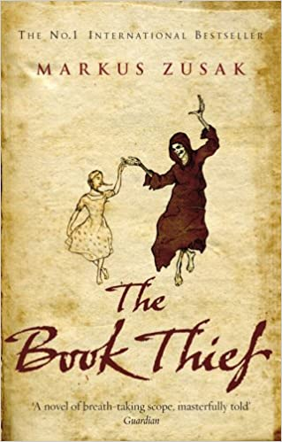
For the fifth task, you read Chapter One of ‘The Book Thief’ by Marcus Zusak and then completed some reading activities.
You are now going to complete one of two writing activities inspired by this text.
You are going to enter a creative writing competition.
You can either:
Write a description suggested by this picture.
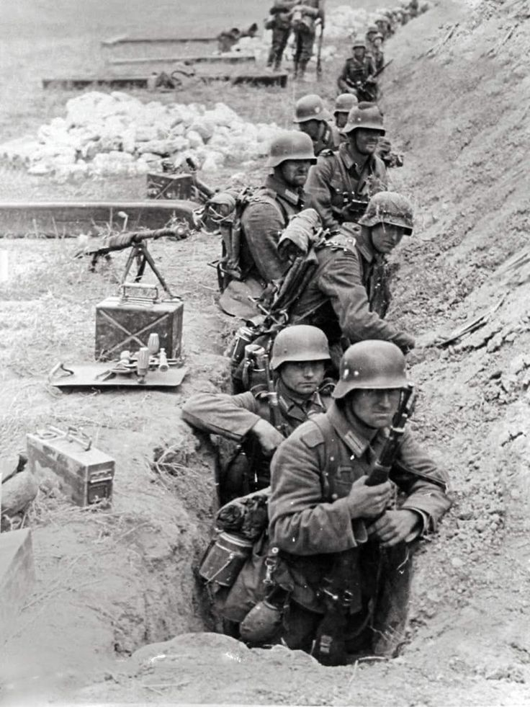
Or write the opening part of a story about a stolen item.

SUCCESS CRITERIA:
- Use powerful adjectives and verbs;
- Use a range of language techniques e.g. similes, metaphors, personification, pathetic fallacy etc.;
- Use a range of sentence lengths;
- Use a range of punctuation accurately;
- Organise your ideas into paragraphs.

…………………………………………………………………………………………………………………………………………………………….
…………………………………………………………………………………………………………………………………………………………….
…………………………………………………………………………………………………………………………………………………………….
…………………………………………………………………………………………………………………………………………………………….
…………………………………………………………………………………………………………………………………………………………….
…………………………………………………………………………………………………………………………………………………………….
…………………………………………………………………………………………………………………………………………………………….
…………………………………………………………………………………………………………………………………………………………….
…………………………………………………………………………………………………………………………………………………………….
…………………………………………………………………………………………………………………………………………………………….
…………………………………………………………………………………………………………………………………………………………….
…………………………………………………………………………………………………………………………………………………………….
…………………………………………………………………………………………………………………………………………………………….
…………………………………………………………………………………………………………………………………………………………….
…………………………………………………………………………………………………………………………………………………………….
…………………………………………………………………………………………………………………………………………………………….
…………………………………………………………………………………………………………………………………………………………….
…………………………………………………………………………………………………………………………………………………………….
…………………………………………………………………………………………………………………………………………………………….
…………………………………………………………………………………………………………………………………………………………….
…………………………………………………………………………………………………………………………………………………………….
…………………………………………………………………………………………………………………………………………………………….
…………………………………………………………………………………………………………………………………………………………….
…………………………………………………………………………………………………………………………………………………………….
…………………………………………………………………………………………………………………………………………………………….
…………………………………………………………………………………………………………………………………………………………….
…………………………………………………………………………………………………………………………………………………………….
…………………………………………………………………………………………………………………………………………………………….
…………………………………………………………………………………………………………………………………………………………….
…………………………………………………………………………………………………………………………………………………………….
…………………………………………………………………………………………………………………………………………………………….
…………………………………………………………………………………………………………………………………………………………….
…………………………………………………………………………………………………………………………………………………………….
…………………………………………………………………………………………………………………………………………………………….
…………………………………………………………………………………………………………………………………………………………….
…………………………………………………………………………………………………………………………………………………………….
…………………………………………………………………………………………………………………………………………………………….
…………………………………………………………………………………………………………………………………………………………….
…………………………………………………………………………………………………………………………………………………………….
…………………………………………………………………………………………………………………………………………………………….
…………………………………………………………………………………………………………………………………………………………….
…………………………………………………………………………………………………………………………………………………………….
…………………………………………………………………………………………………………………………………………………………….
…………………………………………………………………………………………………………………………………………………………….
…………………………………………………………………………………………………………………………………………………………….
…………………………………………………………………………………………………………………………………………………………….
…………………………………………………………………………………………………………………………………………………………….
…………………………………………………………………………………………………………………………………………………………….
…………………………………………………………………………………………………………………………………………………………….
…………………………………………………………………………………………………………………………………………………………….
…………………………………………………………………………………………………………………………………………………………….
…………………………………………………………………………………………………………………………………………………………….
…………………………………………………………………………………………………………………………………………………………….
…………………………………………………………………………………………………………………………………………………………….
…………………………………………………………………………………………………………………………………………………………….
…………………………………………………………………………………………………………………………………………………………….
…………………………………………………………………………………………………………………………………………………………….
…………………………………………………………………………………………………………………………………………………………….
…………………………………………………………………………………………………………………………………………………………….
…………………………………………………………………………………………………………………………………………………………….
…………………………………………………………………………………………………………………………………………………………….
…………………………………………………………………………………………………………………………………………………………….

