


World Book Day
Thursday 5th March 2020

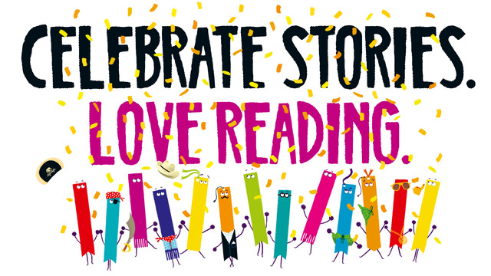

The book openings you’ll be hearing across the day are from:
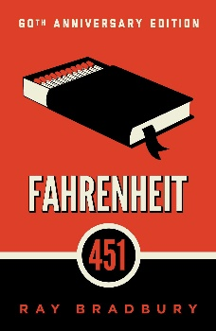
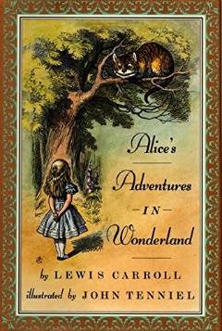
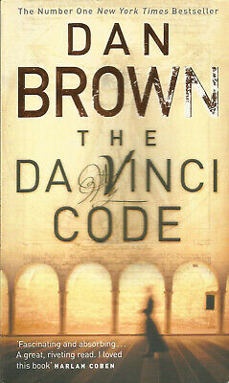
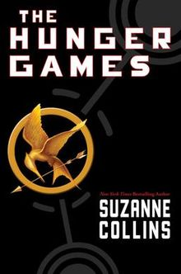
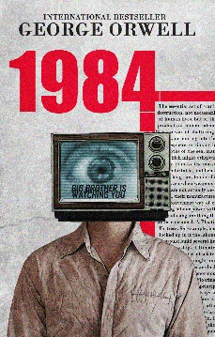

Want to find out what happens next? All these books are available in the Library!
Fahrenheit 451 by Ray Bradbury published in 1954.
It was a pleasure to burn. It was a special pleasure to see things eaten, to see things blackened and changed. With the brass nozzle in his fists, with this great python spitting its venomous kerosene upon the world, the blood pounded in his head, and his hands were the hands of some amazing conductor playing all the symphonies of blazing and burning to bring down the tatters and charcoal ruins of history. With his symbolic helmet numbered 451 on his solid head, and his eyes all orange flame with the thought of what came next, he flicked the igniter and the house jumped up in a gorging fire that burned the evening sky red and yellow and black. He strode in a swarm of fireflies. He wanted above all, like the old joke, to shove a marshmallow on a stick in the furnace, while the flapping pigeon-winged books died on the porch and lawn of the house. While the books went up in sparkling whirls and blew away on a wind turned dark with burning.

1984 by George Orwell published in 1949
It was a bright cold day in April, and the clocks were striking thirteen. Winston Smith, his chin nuzzled into his breast in an effort to escape the vile wind, slipped quickly through the glass doors of Victory Mansions, though not quickly enough to prevent a swirl of gritty dust from entering along with him.
The hallway smelt of boiled cabbage and old rag mats. At one end of it a coloured poster, too large for indoor display, had been tacked to the wall. It depicted simply an enormous face, more than a metre wide: the face of a man of about forty-five, with a heavy black moustache and ruggedly handsome features. Winston made for the stairs. It was no use trying the lift. Even at the best of times it was seldom working, and at present the electric current was cut off during daylight hours. It was part of the economy drive in preparation for HateWeek. The flat was seven flights up, and Winston, who was thirty-nine and had a varicose ulcer above his right ankle, went slowly, resting several times on the way. On each landing, opposite the lift shaft, the poster with the enormous face gazed from the wall. It was one of those pictures which are so contrived that the eyes follow you about when you move. BIG BROTHER IS WATCHING YOU, the caption beneath it ran.

The Da Vinci Code by Dan Brown published in 2000
Louvre Museum, Paris 10:46 P.M.
Renowned curator Jacques Saunière staggered through the vaulted archway of the museum's Grand Gallery. He lunged for the nearest painting he could see, a Caravaggio. Grabbing the gilded frame, the seventy-six-year-old man heaved the masterpiece toward himself until it tore from the wall and Saunière collapsed backward in a heap beneath the canvas.
As he had anticipated, a thundering iron gate fell nearby, barricading the entrance to the suite. The parquet floor shook. Far off, an alarm began to ring.
The curator lay a moment, gasping for breath, taking stock. I am still alive. He crawled out from under the canvas and scanned the cavernous space for someplace to hide.
A voice spoke, chillingly close. "Do not move."
On his hands and knees, the curator froze, turning his head slowly.
Only fifteen feet away, outside the sealed gate, the mountainous silhouette of his attacker stared through the iron bars. He was broad and tall, with ghostpale skin and thinning white hair. His irises were pink with dark red pupils. The albino drew a pistol from his coat and aimed the barrel through the bars, directly at the curator. "You should not have run." His accent was not easy to place. "Now tell me where it is."

The Hunger Games by Suzanne Collins published in 2008
When I wake up, the other side of the bed is cold. My fingers stretch out, seeking Prim’s warmth but finding only the rough canvas cover of the mattress. She must have had bad dreams and climbed in with our mother.
Of course she did. This is the day of the reaping.

I prop myself up on one elbow. There’s enough light in the bedroom to see them. My little sister, Prim, curled up on her side, cocooned in my mother’s body, their cheeks pressed together. In sleep, my mother looks younger, still worn but not so beaten-down. Prim’s face is as fresh as a raindrop, as lovely as the primrose for which she was named. My mother was very beautiful once, too. Or so they tell me.

Alice in Wonderland by Lewis Carroll published in 1865

Alice was beginning to get very tired of sitting by her sister on the bank, and of having nothing to do: once or twice she had peeped into the book her sister was reading, but it had no pictures or conversations in it, `and what is the use of a book,' thought Alice `without pictures or conversation?'
So she was considering in her own mind (as well as she could, for the hot day made her feel very sleepy and stupid), whether the pleasure of making a daisy-chain would be worth the trouble of getting up and picking the daisies, when suddenly a White Rabbit with pink eyes ran close by her.
There was nothing so very remarkable in that; nor did Alice think it so very much out of the way to hear the Rabbit say to itself, `Oh dear! Oh dear! I shall be late!' (when she thought it over afterwards, it occurred to her that she ought to have wondered at this, but at the time it all seemed quite natural); but when the Rabbit actually took a watch out of its waistcoat-pocket, and looked at it, and then hurried on, Alice started to her feet, for it flashed across her mind that she had never before seen a rabbit with either a waistcoat-pocket, or a watch to take out of it, and burning with curiosity, she ran across the field after it, and fortunately was just in time to see it pop down a large rabbit-hole under the hedge.

