Mrs Vince is reading....

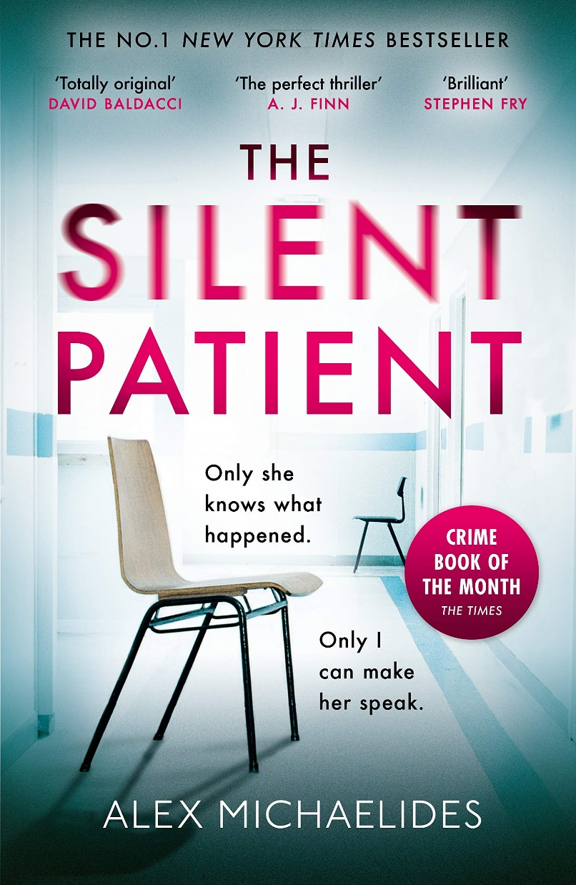
I downloaded the Kindle copy of this book as it was on offer for 99p and I haven’t read a thriller for a while – also, the reviews on Amazon were really good.
It’s about a wife who is found at the murder of her husband who has been shot 5 times in the face. She is immediately arrested and from that point she becomes mute – she doesn’t say a thing. As an artist, the only way she communicates is through art. After the murder, she painted a self-portrait called ‘Alcestis’ which is a Greek tragedy.
Her therapist reads the tragedy which starts to give him clues about her potential motive. We also have her diary entries to read. I have no idea if she killed him or not and I can’t wait to find out!

What are you reading?

